CPSC 1030 Project Proposal

Jay Seung Yeon Lee

100357736

1. List of my 5 websites

* ResumeGenius : This website will be used for me to remind myself what to include in a good resume

https://resumegenius.com/blog/resume-help/what-to-put-on-a-resume?utm_source=google&utm_medium=cpc&utm_term=&utm_campaign_id=11128721026&utm_adgroup_id=108314698039&utm_content=464730100924&utm_device=c&gclid=CjwKCAiAzNj9BRBDEiwAPsL0d5sMYaZPPxCNq9EbSgIYzmpNbPpu9bAh4-20Smj9AyH2RhmguKbSxRoCSBwQAvD_BwE

* Webpage I could use as a reference:

This page has 20 different outstanding webpage resumes I can use as a reference .

<https://zyro.com/blog/resume-website-examples/>

* Webpage with Personal Resume Websites/Personal Portfolios/Personal Blogs/ Personal Demo Websites

This webpage includes all I need to use as a reference. When I went through the list, I found it inspiring how they designed their pages and blogs. Gave me a lot of ideas

<https://blog.hubspot.com/marketing/best-personal-websites>

* Some knowledge about the formats of the resume ( Chronological, Functional, and Combination)

<https://www.resume-now.com/resume/formats?utm_source=google&utm_medium=sem&utm_campaign=1378719298&utm_term=&network=g&device=c&adposition=&adgroupid=50359242370&placement=&gclid=CjwKCAiA7939BRBMEiwA-hX5J0oCXg8AuoXtaRDeOYVRkz1nfOEzKlE8Yh7QK3vqVk_Td7aJCTXCQhoCDdEQAvD_BwE>

* Things you should be aware of writing a resume

<https://careers.workopolis.com/advice/10-things-you-should-know-when-writing-your-first-resume/>

1. List of all pages I plan to include

* Index.html (Brief Self introduction) – There will be a nav bar fixed at the right-hand corner

Background image will be an image of myself. My name will be in h1, text aligned to center. There will be a button that will say “Email me”, and links for my SNS pages. At the bottom (about 3 quarters down from top) will say “I am the piece your team is looking for”.

* More about myself (background and passion)

Second page will be more about myself. Specifically, about my background and my passion along with some of my skills.

* Work experience and Education

List of my previous/ current job and history of my education ++ and courses.

* My inspiration and hi-lighting my contact info again.

I would like to talk about what inspires me and re-hilight my contact info on the last page of my resume

1. Screenshots of wireframe.cc

My index.html

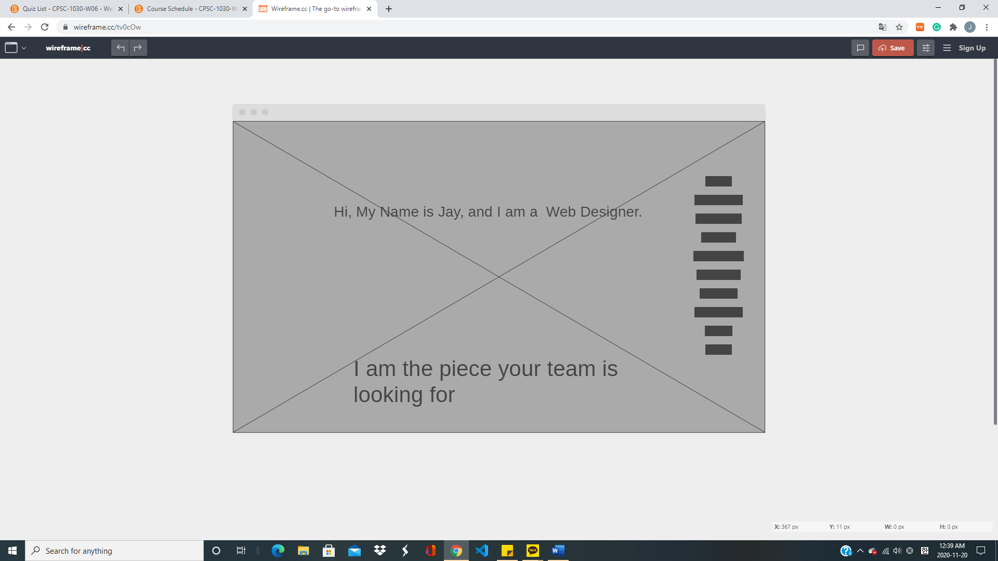

And again, gray part at the back will be a background image of myself, and the shapes on the right will be my nav bar fixed at the right-hand side.

My second page will be about my background and passion/skills.

This is for screen over 800px in width.

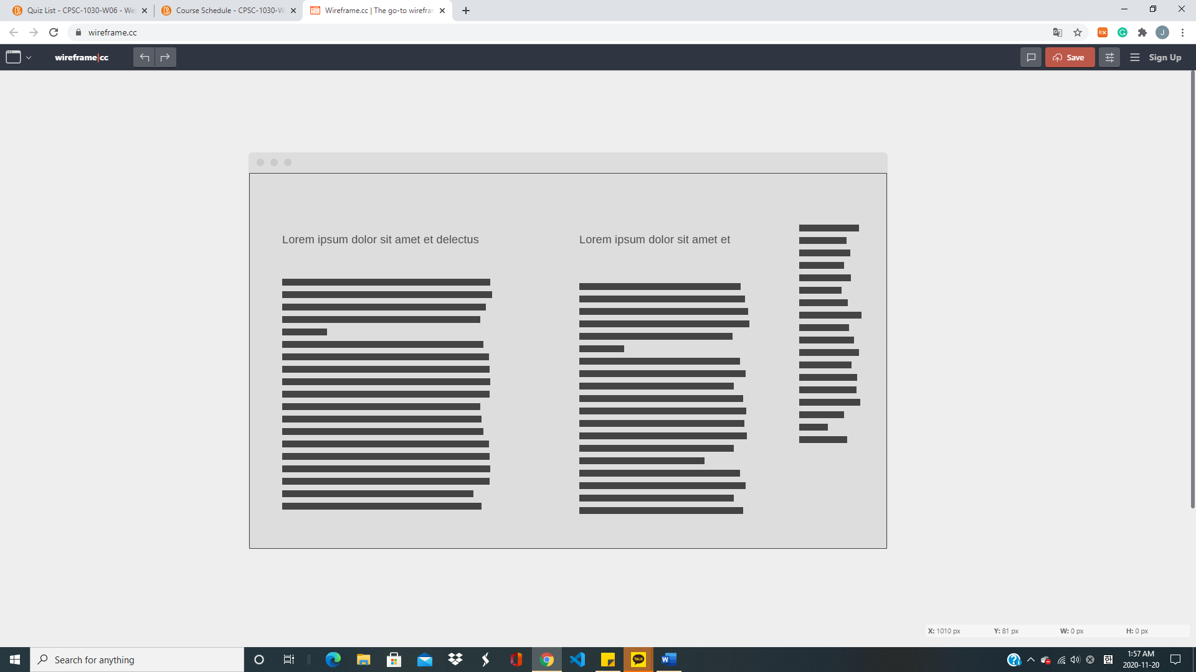

First paragraph from the left will be about my background and my passion for web designing. Second paragraph will be about list of my skills. Paragraph on the right represents my nav bar which will be fixed on the right-hand side of the page.

This is for screen width less than 800 px.

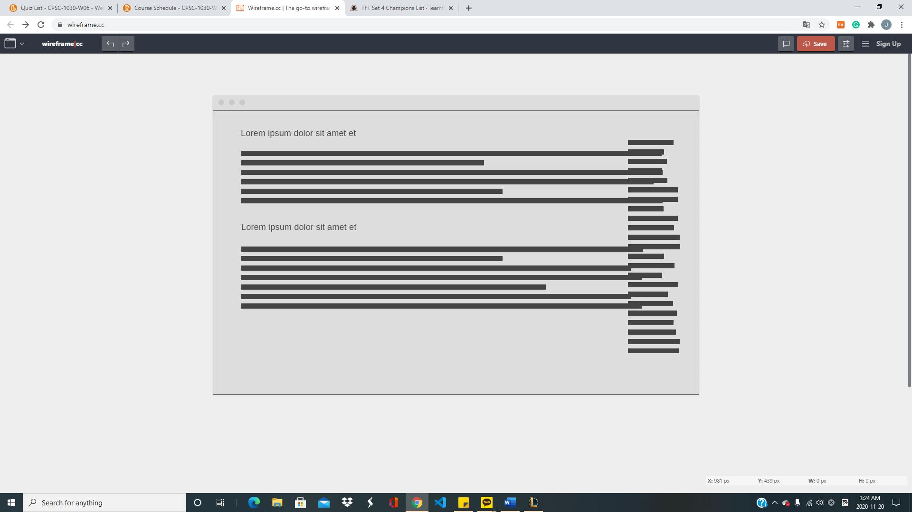

First paragraph from the top will be about my background and my passion for web designing. Second paragraph will be about list of my skills. Paragraph on the right represents my nav bar which will be fixed on the right-hand side of the page.